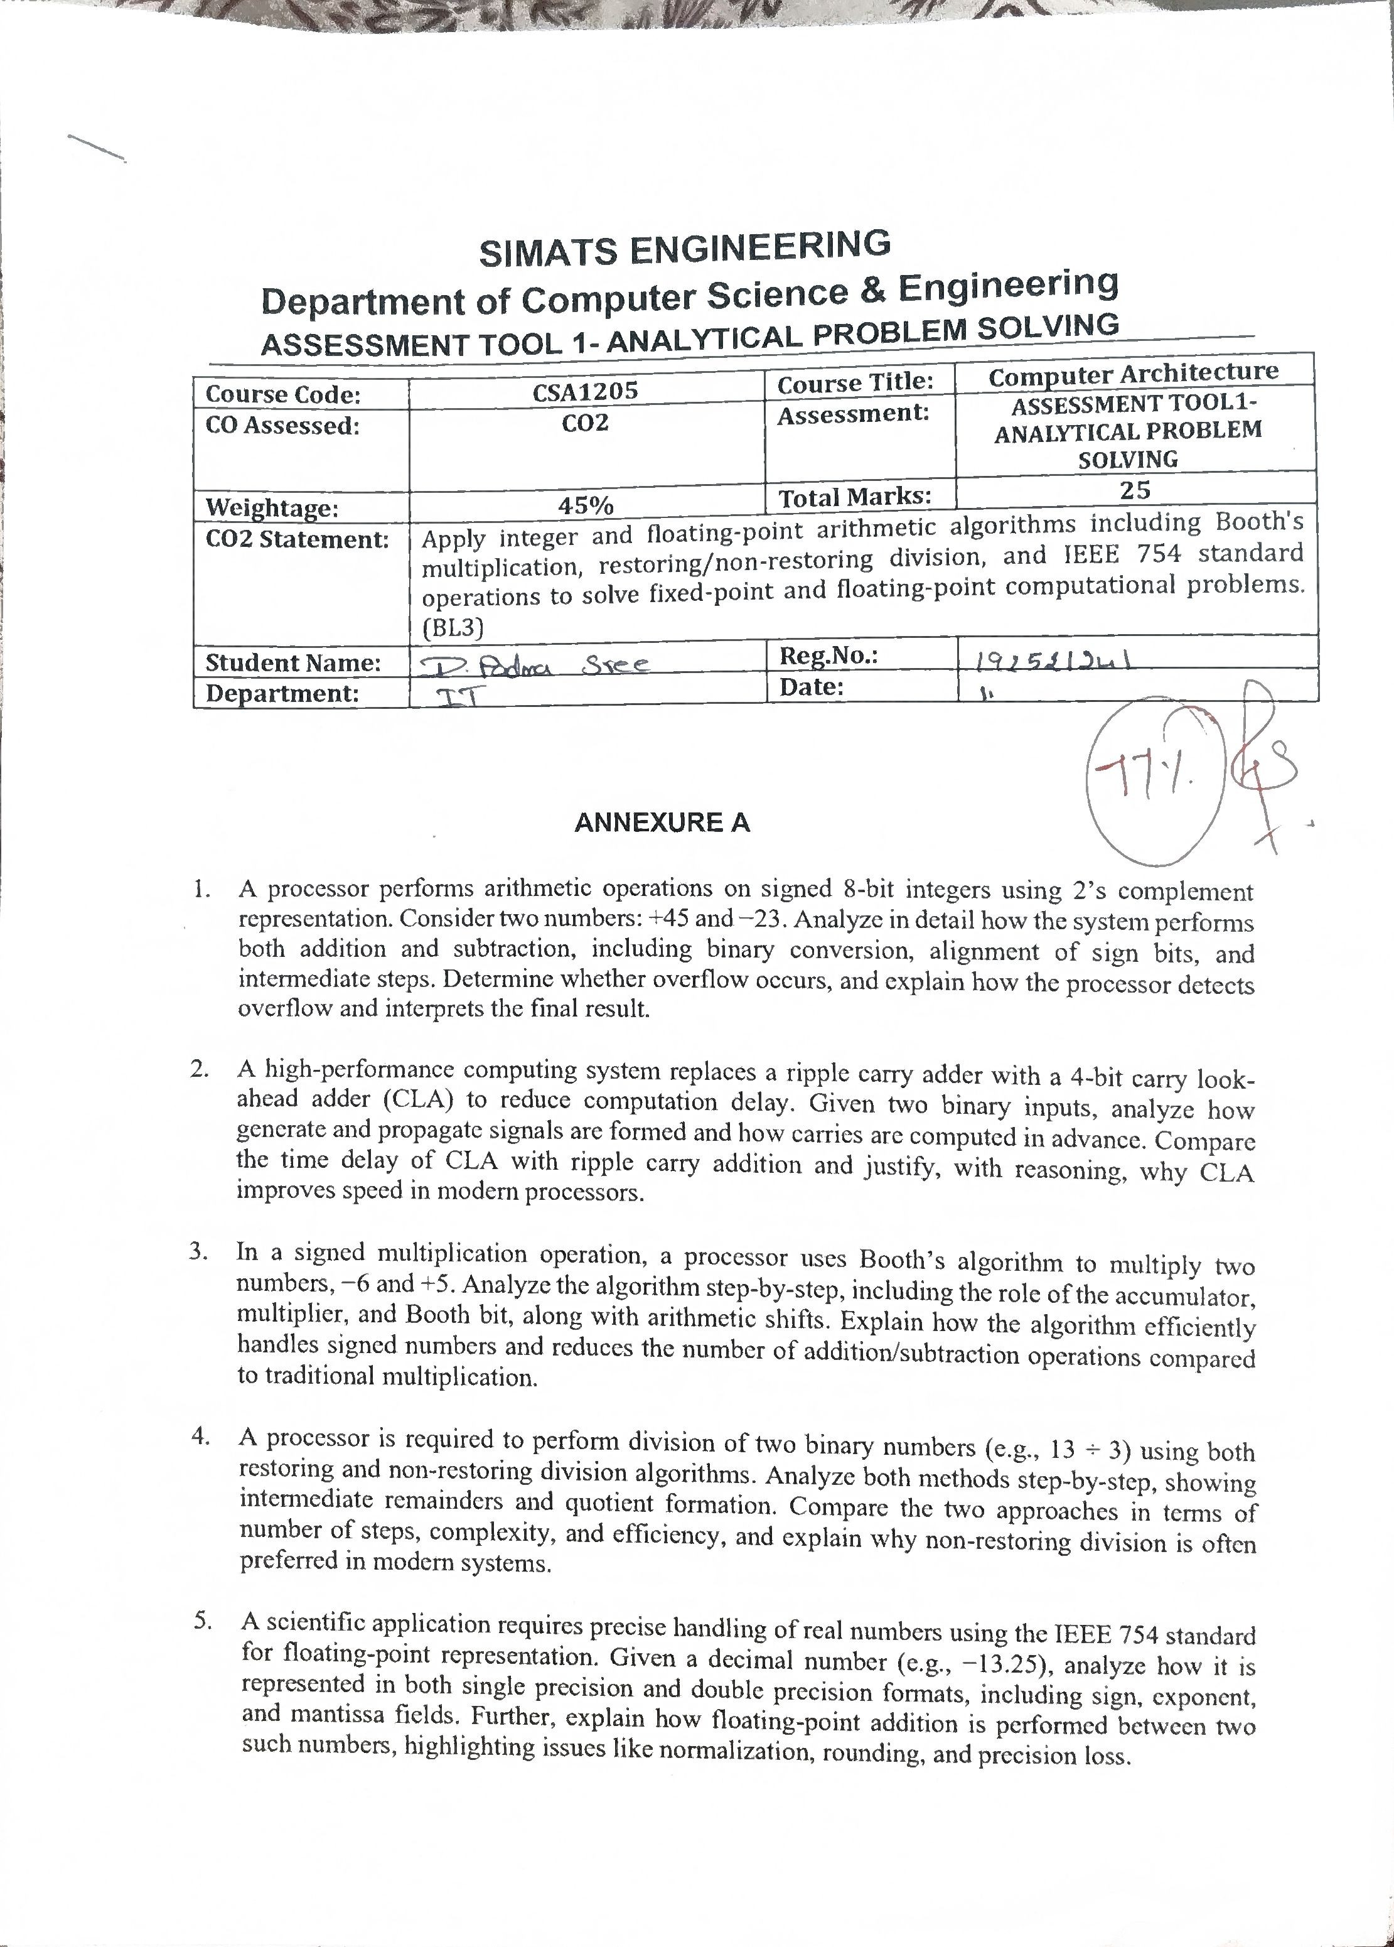

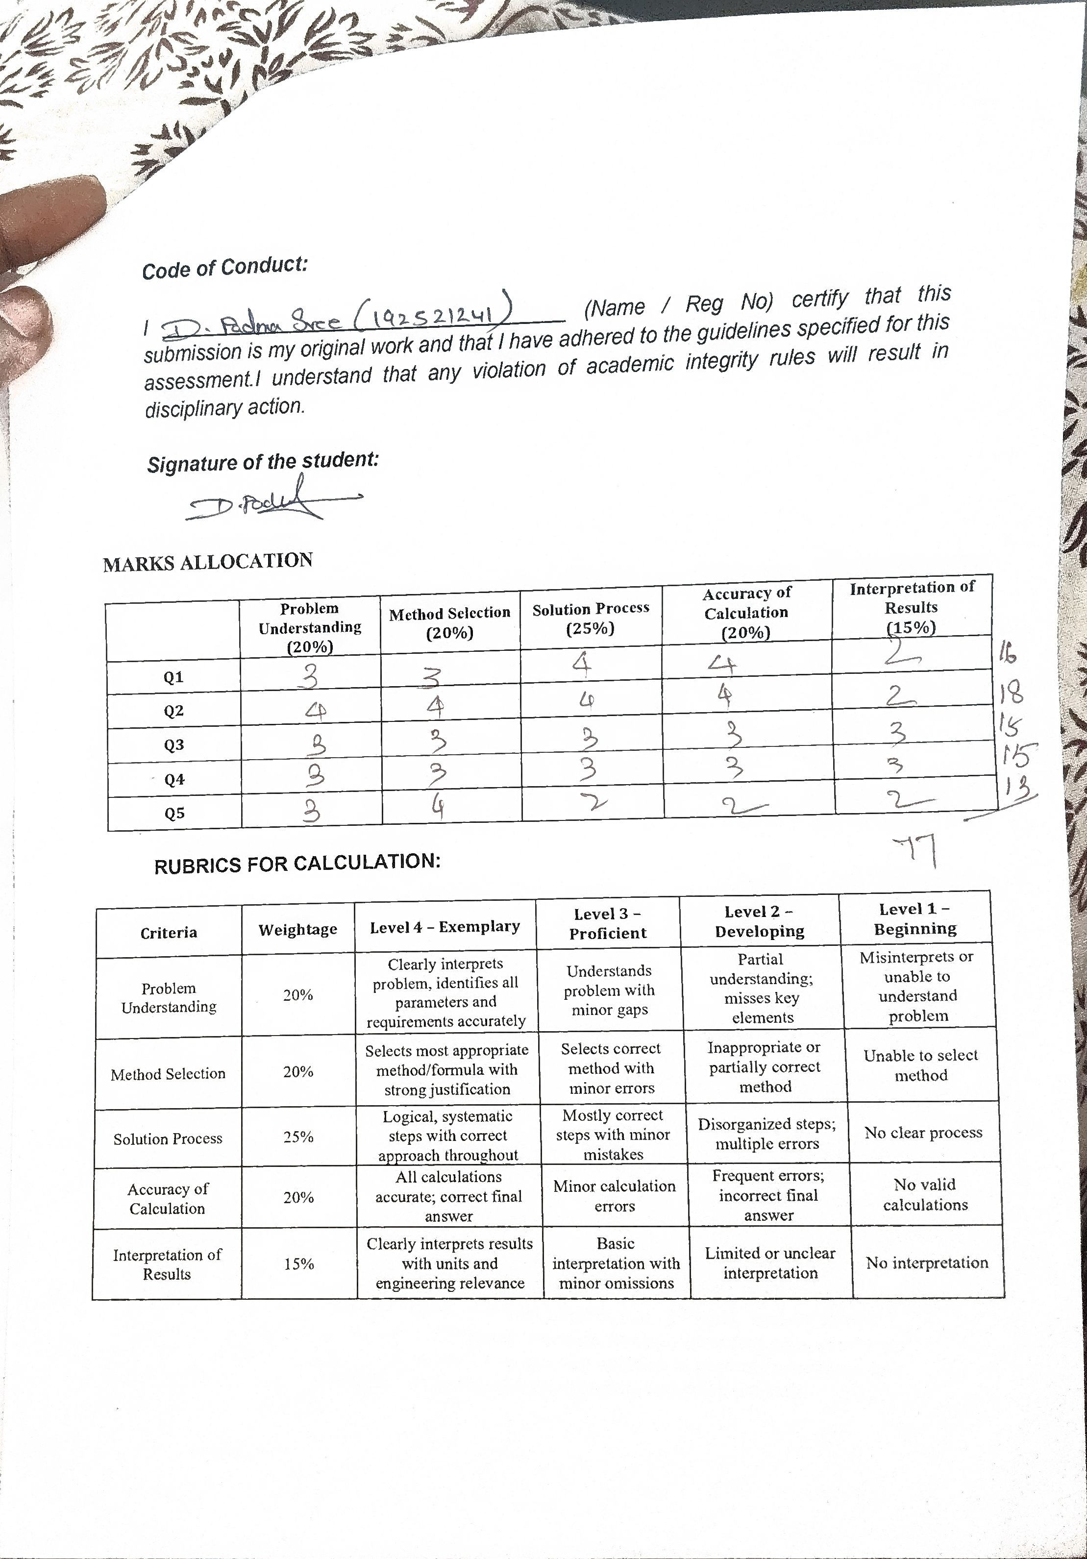

Q1.Signed 8-bit Addition and Subtraction:
Given:
+45 and −23
Binary conversion:
+45 = 00101101
+23 = 00010111
−23 using 2’s complement:
1’s complement = 11101000
+1 = 11101001 Addition:
00101101 (+45)
+ 11101001 (-23)
-----------
00010110

00010110 = +22
Subtraction:
(+45) − (−23) = 45 + 23

00101101
+ 00010111
-----------
01000100
01000100 = +68

Overflow:
No overflow occurs because both results are within the 8-bit signed range−128 to +127.
Answer:
Addition = +22, Subtraction = +68.

Q2.4-bit Carry Look-Ahead Adder:
A Carry Look-Ahead Adder (CLA) calculates carry signals in advance, reducing addition delay.
For each bit:

• Generate: Gi = Ai · Bi
• Propagate: Pi = Ai  Bi • Carry equation: Ci+1 = Gi + PiCi

For a 4-bit CLA:

C1 = G0 + P0C0

C2 = G1 + P1G0 + P1P0C0

C3 = G2 + P2G1 + P2P1G0 + P2P1P0C0

C4 = G3 + P3G2 + P3P2G1 + P3P2P1G0 + P3P2P1P0C0 The sum is:
Si = Pi  Ci

Comparison

Ripple Carry Adder | Carry Look-Ahead Adder
Carry moves bit-by-bit | Carries calculated in parallel
More delay | Less delay
Simple circuit | More complex circuit
Slower for large adders | Faster for large adders
Conclusion
CLA reduces propagation delay because carries are calculated simultaneously. Hence, it is useful in high-speed processors and ALUs.

Q3. Booth’s Algorithm: −6 × +5:
Use 4-bit 2’s complement. • Multiplicand M = −6 = 1010
- Multiplier Q = +5 = ₀₁₀₁
- Accumulator A = ₀₀₀₀
- Booth bit Q−1 = 0

Rules:
Q0 Q−1 | Operation
00 | No operation
11 | No operation
01 | A=A+M
10 | A=A-M
Steps
Step | Q0Q−1 | Operation | A
1 | 10 | A = A − M | 0110
2 | 10 | A = A − M | 1100
3 | 01 | A = A + M | 0110
4 | 10 | A = A − M | 1100
After every operation, an arithmetic right shift is performed on _{A, Q, Q−1}.
Final 8-bit product:
AQ = 11100010
11100010 in 2’s complement = −30.
Therefore:
−6 × +5 = −30

Advantages of Booth’s Algorithm
- Handles positive and negative numbers directly.
- Uses 2’s complement arithmetic.
- Reduces the number of additions/subtractions when consecutive 1s occur.
- Suitable for signed multiplication in processors.
Q4. Restoring and Non-Restoring Division: 13 ÷ 3:
Given:
- Dividend = 13 = ₁₁₀₁
- Divisor = 3 = ₀₀₁₁
Expected result:
13 ÷ 3 = 4 remainder 1 A. Restoring Division
Basic procedure:
- Shift the partial remainder and quotient left.
- Subtract the divisor.
- If result is negative, restore the previous remainder and put quotient bit = 0.
- If result is positive, keep it and put quotient bit = 1.
- Repeat for all bits.
For _{1101 ÷ 0011}, after four iterations:
Quotient = 0100 = 4
Remainder = 0001 = 1
The important feature is that a negative partial remainder is restored by adding the divisor back.

B. Non-Restoring Division
In non-restoring division:
- If the partial remainder is positive, subtract the divisor.
- If it is negative, add the divisor in the next step.
- Restoration is therefore avoided after every unsuccessful subtraction. • At the end, if the remainder is negative, the divisor is added once.
For 13 ÷ 3:
Quotient = 0100 = 4
Remainder = 0001 = 1
Comparison
Restoring | Non-Restoring
Restores negative remainder | Does not restore immediately
More operations | Fewer operations
Simpler concept | More efficient
More delay | Less delay
Conclusion:
Non-restoring division is generally faster because it avoids repeated restoration operations.
Q5. IEEE 754 Representation of −13.25:
Given decimal number:
−13.25

Step 1: Convert to binary
Integer part:
- = 1101
Fraction:
0.25 = 0.01 Therefore:
13.25 = 1101.01 Normalize:
1101.01 = 1.10101 × 2³

Single Precision — 32 bits
IEEE 754 single precision contains:
- Sign: 1 bit
- Exponent: 8 bits
- Mantissa: 23 bits
For −13.25:
Sign = 1
Exponent = 3 + 127 = 130
130 = 10000010
Mantissa = 10101000000000000000000 Therefore:
1 | 10000010 | 10101000000000000000000 Double Precision — 64 bits
Double precision contains:
- Sign: 1 bit
- Exponent: 11 bits
- Mantissa: 52 bits
Bias = 1023
Exponent = 3 + 1023 = 1026
1026 = 10000000010
Therefore:
1 | 10000000010 | 1010100000000000000000000000000000000000000000000000 Floating-Point Addition
When two floating-point numbers are added:
- Compare their exponents.
- Align the binary points by adjusting the smaller exponent.
- Add/subtract the significands.
- Normalize the result.
- Round the result according to the IEEE 754 rounding mode.
- Store the final sign, exponent and mantissa.

Important issues
- Normalization keeps the significand in the required form.
- Rounding may be necessary when the result has too many bits.
- Precision loss can occur when numbers have very different exponents. • Double precision provides greater precision than single precision.
Final: IEEE 754 provides a standard way to represent and perform arithmetic on real numbers using sign, exponent, and mantissa fields.
Code of Conduct:

I ____________________________________ (Name / Reg No) certify that this submission is my original work and that I have adhered to the guidelines specified for this assessment.I understand that any violation of academic integrity rules will result in disciplinary action.

Signature of the student:

MARKS ALLOCATION
 | Problem  Understanding  (20%) | Method Selection  (20%) | Solution Process  (25%) | Accuracy of  Calculation  (20%) | Interpretation of  Results  (15%)
Q1
Q2
Q3
Q4
Q5

RUBRICS FOR CALCULATION:

Criteria | Weightage | Level 4 – Exemplary | Level 3 –  Proficient | Level 2 –  Developing | Level 1 –  Beginning
Problem Understanding | 20% | Clearly interprets problem, identifies all parameters and  requirements accurately | Understands  problem with minor gaps | Partial understanding; misses key elements | Misinterprets or unable to  understand problem
Method Selection | 20% | Selects most appropriate method/formula with strong justification | Selects correct method with minor errors | Inappropriate or partially correct method | Unable to select method
Solution Process | 25% | Logical, systematic steps with correct approach throughout | Mostly correct steps with minor mistakes | Disorganized steps; multiple errors | No clear process
Accuracy of Calculation | 20% | All calculations accurate; correct final  answer | Minor calculation errors | Frequent errors; incorrect final answer | No valid calculations
Interpretation of Results | 15% | Clearly interprets results with units and  engineering relevance | Basic interpretation with minor omissions | Limited or unclear interpretation | No interpretation

